DIKO Drop Zone Installation and User Guide



V1.0

20190716

# Disclaimer

Copyright 2019. 適時科技有限公司保留本文所有權利。 如沒任何授權，翻印必究。

如有任何疑問，請電郵至 info@si-taiwan.com 查詢。

# Table of Contents

Disclaimer 2

Table of Contents 3

1.Requirements 4

2. Install Microsoft WSE 2.0 SP3 5

3. Installing DropZone in Windows 8

4. DIKO DROP ZONE System Settings 16

5. Using DIKO DROP ZONE 18

# Requirement

OS

-Windows 7/8/10

Modules

- Microsoft WSE 2.0 SP3

# Install Microsoft WSE 2.0 SP3

|  |  |
| --- | --- |
| Steps | Instructions |
| 2.1 | Double click“Microsoft WSE 2.0 SP3” and start installation |
|  |  |
| Steps | Instructions |
| 2.2 | Select “Next > ” |
|  | |

|  |  |
| --- | --- |
| Steps | Instructions |
| 2.3 | Choose “I accept the terms in the license agreement” then select “Next” |
|  | |

|  |  |  |
| --- | --- | --- |
| Steps | Instructions | |
| 2.4 | Choose “Runtime” then click “Next” | |
|  | | |
| Steps | | Instructions |
| 2.5 | | Click “Install” |

|  |  |
| --- | --- |
|  | |
| Steps | Instructions |
| 2.6 | Upon completion click “Finish” |
|  | |

# Installing DropZone in Windows

|  |  |  |
| --- | --- | --- |
| Steps | Instructions | |
| 3.1 | Double click “DIKO DropZone Setup” begin installation | |
|  | | |
| Steps | | Instructions |
| 3.2 | | Click “Next >” |
|  | | |
| Steps | | Instructions |
| 3.3 | | Click “Next >” |
|  | | |

|  |  |
| --- | --- |
| Steps | Instructions |
| 3.4 | Click “Install” |
|  | |
| Steps | Instructions |
| 3.5(If the below image shows up, select this  place) | Click“Download and install this feature” |
|  | |
| Steps | Instructions |

|  |  |  |
| --- | --- | --- |
| 3.6 | | Click “Finish” |
|  | | |
| Steps | Instructions | |
| 3.7 | Right click “DIKO DropZone” | |
|  | | |
| Steps | Instructions | |
| 3.8 | Select “Properties (R)” and then“Compatibility” | |

|  |  |  |
| --- | --- | --- |
|  | 然後“Change settings for all users” 然後  “Run this program as an administrator” | |
|  | | |
| Steps | | Instructions |
| 3.9 | | 點選「Blueprint:」旁的選擇儲存路徑，點擊「Generate H/W Blueprint」： |
|  | | |

|  |  |
| --- | --- |
| Steps | Instructions |
| 3.10 | 把「Blueprint.txt」傳給賣家 |
|  |  |
| Steps | Instructions |
| 3.11 | 把賣家傳給您的 KEY 貼上並點擊  “Activate” |
|  | |

|  |  |
| --- | --- |
| Steps | Instructions |
| 3.12 | 成功載入「DIKO Drop Zone」界面。系統要求您為首次執行的系統進行設定。點擊  「Yes」接受，又或點擊「No」跳過，先行設定用戶界面的語言。 |
|  | |
| Steps | Instructions |
| 3.13 | 到“Settings”、“Language”並選擇“繁體中文” |

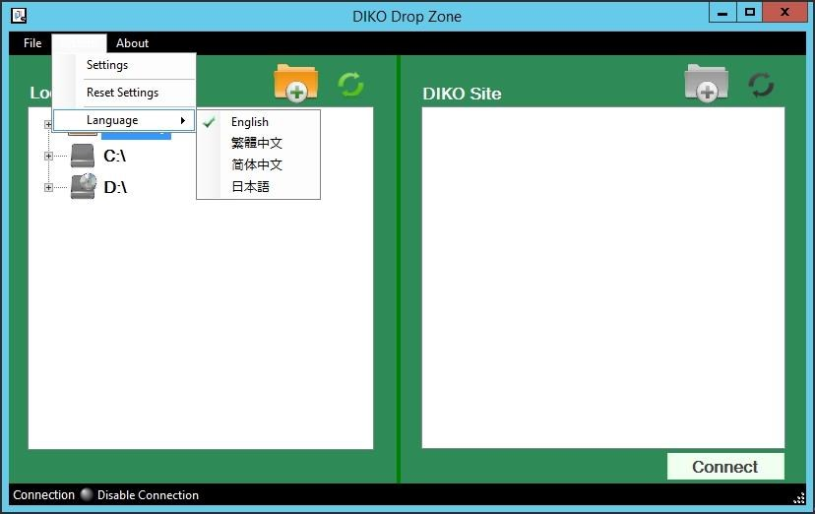

# DIKO Drop Zone 系統設置

|  |  |
| --- | --- |
| Steps | Instructions |
| 4.1 | 進入 “DIKO Drop Zone” 界面，點擊 “系  統”，點擊 “設定” |
|  | |
| Steps | Instructions |
| 4.2 | 請在「服務地址:」輸入您的 DIKO 伺服器的地址，然後在「使用者帳號:」及「密碼:」輸  入 DIKO 的帳號名稱及密碼，然後按「儲存」。 |
|  | |
|  | |

# 使用 DIKO Drop zone

|  |  |
| --- | --- |
| Steps | Instructions |
| 5.1 | 系統設置之後, 點擊”連接” |
|  | |

|  |  |
| --- | --- |
| Steps | Instructions |
| 5.2 | 成功連接後 將在右側顯示 DIKO 的資料夾 |

|  |  |
| --- | --- |
|  | |
| Steps | Instructions |
| 5.3 | 可以直接把要下載或上傳的資料拖放到相對位置 |

步驟

說明

5.4

可以直接把要下載或上傳的資料

拖放

到相對位

置

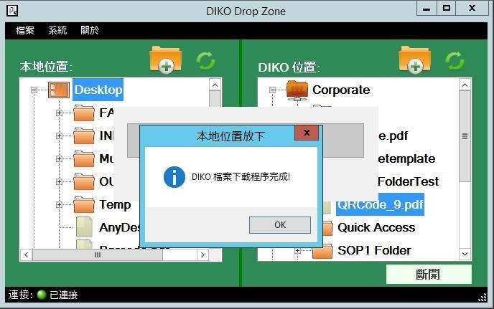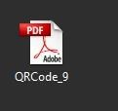

|  |  |
| --- | --- |
|  | |
| Steps | Instructions |
| 5.5 | 點擊 “斷開 ”並結束工作 |
|  | |